Assignment 1

- Understanding:
  - write a program which assigns and prints the values of each datatype in C
- Design:
  - the program sould assign some values to each of the basic datatypes in C
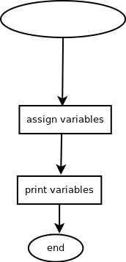

- Testing:
 | Input | Expected output | Actual output
Short | 32767 | Short = 32767 | Short = 32767
Int | 7483647 | Int = 7483647 | Int = 7483647
Long | 2147483647 | Long = 2147483647 | Long = 2147483647
Float | 3.456237 | Float = 3.45624 | Float = 3.45624
Double | 1.753651984571356 | Double = 1.75365 | Double = 1.75365
Long double | 1.126495873156497821 | Long double = 3.45846e-323 | Long double = 3.45846e-323
Char | ‘h’ | Char = h | Char = h
CharString | “CS133C” | String = CS133C | String = CS133C

- Reflection: now that you are done with your program (even if the program is not complete!) you should discuss the process. You should mention things like:
  - In the case of this assignment, it was pretty straightforward to understand. As such, I do believe that I have understood it correctly.
  - All of my tests turned out as expected. I did modify the final output to make it a bit easier to read instead of having the minimum amount of whitespace.
  - Implementation went without a hitch, as previously stated, this is a pretty easy assignment. I did find the method of string substitution interesting in that there are different substitution variables for the different datatypes.
  - One thing that is fairly easy to overlook is the afrementioned substitution variables. In other languages such as Java and python, they are just that, variables, or placeholders that just sit there until they are assigned as actual value. In C, there are several different substitution variables, all of which stand for a different datatype. On top of that, there are several modifiers which modify the length of the output.
  - The biggest technique is that of googling. As with all programming, the best two skills to learn are how to logic in a way that the computer understands and how to google for the answer you are looking for, because someone else has probably already solved that problem and you just need to find it.

